Project 6 Documentation:

Test Plan:

|  |  |  |  |
| --- | --- | --- | --- |
| **Cases** | **Input** | **Expected Result** | **Actual Result** |
| 1 (enter info correctly) | 1122  20000  4.5  2500  3000 | Your current balance: $20500.00 | Your current balance: $20500.00 |
| 2 (withdraw more than balance) | 1122  10000  20000 | Can not withdraw. Insufficient funds. | Can not withdraw. Insufficient funds. |
| 3 (negative account balance) | 1122  -10000  20000 | Balance can not be negative. Please Re-enter: | Please enter account balance:  -10000  Balance can not be negative. Please Re-enter:  20000 |

Screenshots:

Case 1:

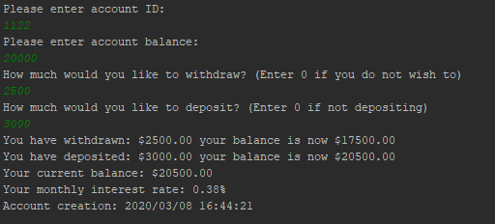

Case 2:

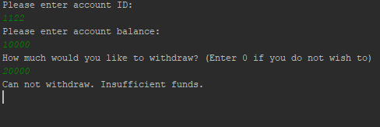

Case 3:

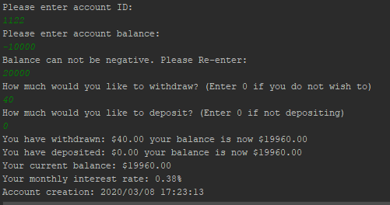

UML diagram:

|  |
| --- |
| **Class Name:**  **Account** |
| Private int: id  Private double: balance  Private double: annualInterestRate  Private String: date |
| **+Account(): void**  **+getID(): int**  **+getBalance(): double**  **+getAnnualInterestRate(): double**  **+setId(): void**  **+setBalance(): void**  **+setAnnualInterestRate (): void**  **+getMonthlyInterestRate(): String**  **+dateCreated(): String**  **+withdraw(): void**  **+deposit(): void** |

